horizontal line

**School of Engineering and Applied Science(SEAS), Ahmedabad University**

**B.Tech Semester IV: Database Management Systems**

**(CSE250)**

**Topic: Organ Bank Database Management System**

**Faculty: Shefali Naik**

**Section-1, Group: 57**

**Students' details**

|  |  |
| --- | --- |
| **Enrollment No.** | **Name of the Student** |
| AU1940124 | Sanskruti Shingala |
| AU1940173 | Priya Bhoraniya |
| AU1940195 | Krinal Boghani |

**1.1 Introduction:**

The Organ Bank Database Management System (DBMS) refers to the technology for creating and managing data of donors, organs, coordinating institutes and recipients for an organ bank. The main aim of this project is to computerize the manual process of managing data of Organ Banks. The process starts when Organ Bank arranges donation camps. In those donation camps, people donate the organs and the record of that is then handed over to DBMS. Organ banks have many coordinating institutes through which it provides service to the needy people. Therefore, Organ Bank matches the data of available organs with the data of recipients. However, organs can be only available after brain death testing of the donor(not necessary in the case of kidney and liver) and therefore a waiting list has been provided. Further, when any organ reaches the organ bank, a matching process has been done and transplanted to the one highest on the waiting list. Hence this whole data can be easily managed by the DBMS. On the basis of this process we have designed the database management system.

Our system can be used by two users i.e. Organ Bank and coordinating hospitals. Both users have certain privileges to watch and manipulate data.

The services of a organ bank can include:

* Handling donor, organ, coordinator, recipient details
* Preparing the waiting list for recipients
* Matching process of organs
* Handling camps

The services of coordinating Hospitals can include:

* Add and manage data of recipient of their institute
* Check Organ Availability
* View information of Camps
* View waiting List

**Used Languages and Softwares**

Front-end ⇒ HTML,CSS,Bootstrap

Back-end ⇒ MySQL

Front-end Database connectivity ⇒ PHP, javascript

FlowChart and ER Diagram ⇒ MIRO

Data Dictionary Tables ⇒ MySQL Workbench

**1.2 Design of Project**

**1.2.1 Flow of Project**

The flow starts from the home page where introductory details of the organ donation bank have been displayed. However, the admin of the bank and hospitals have to log in for managing the data. After successful login, services of hospitals and the bank can be accessible. Hospitals can view the waiting list, data of available organs, camps and can add recipients. However, the admin of the bank has privileges to add, update and delete the data of donors, recipients, organs, and camps. The admin can also do matches of organs for recipients on the waiting list. Further, it also keeps the data of transplants.

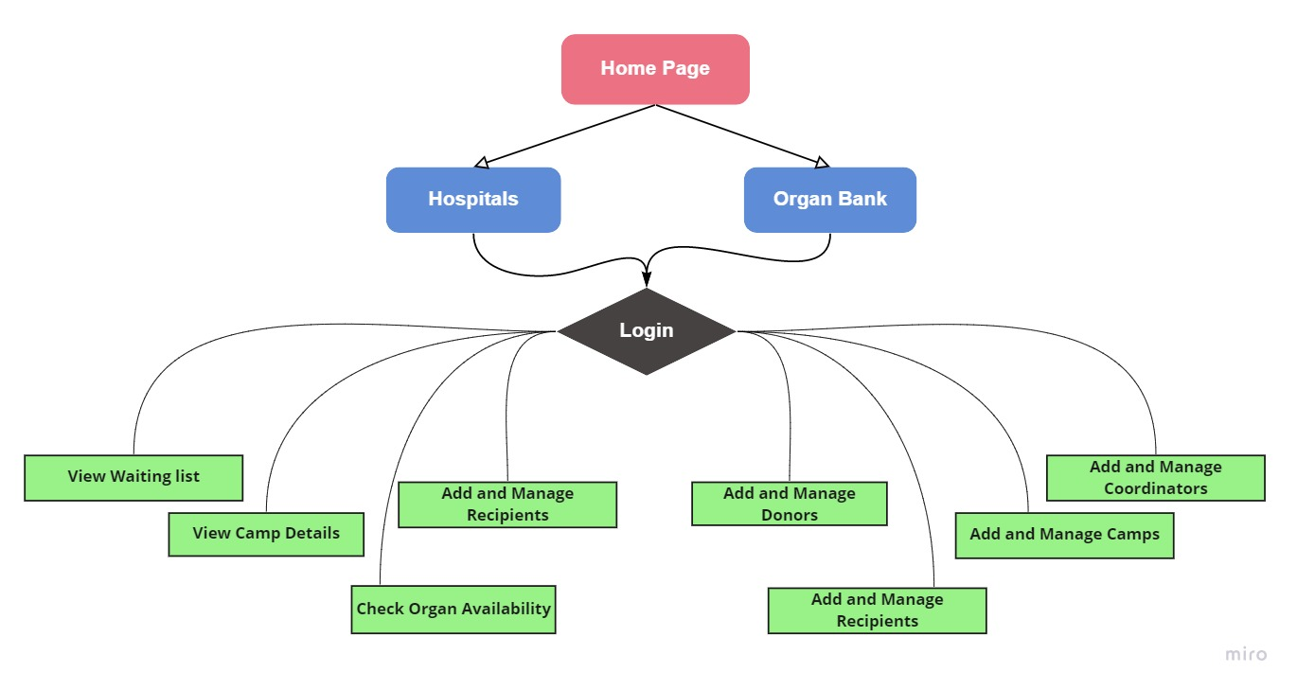

**1.2.2 ER Diagram**

**Relationships**

1. camp→donor (1-M)
2. donor→organ(1-M)
3. Donor→medical_details (1-1)
4. organ→medical_details(1-1)
5. coordinators→recipient(1-M)
6. recipient→recipient_details(1-1)
7. donor→address(1-1)
8. recipient→address(1-1)
9. coordinators→ins_address(1-1)
10. recipient→transplant(1-0)
11. recipient→waiting_list(1-0)

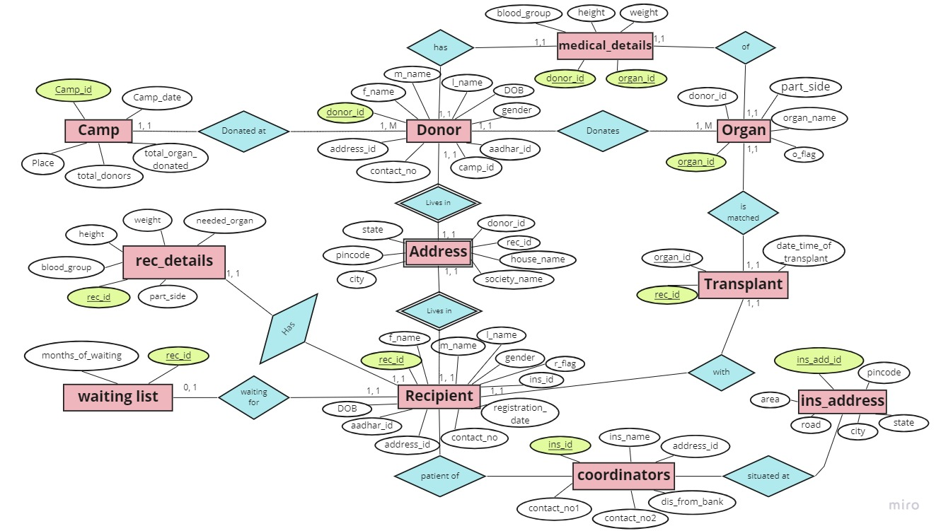

**1.2.3 Data Dictionary**

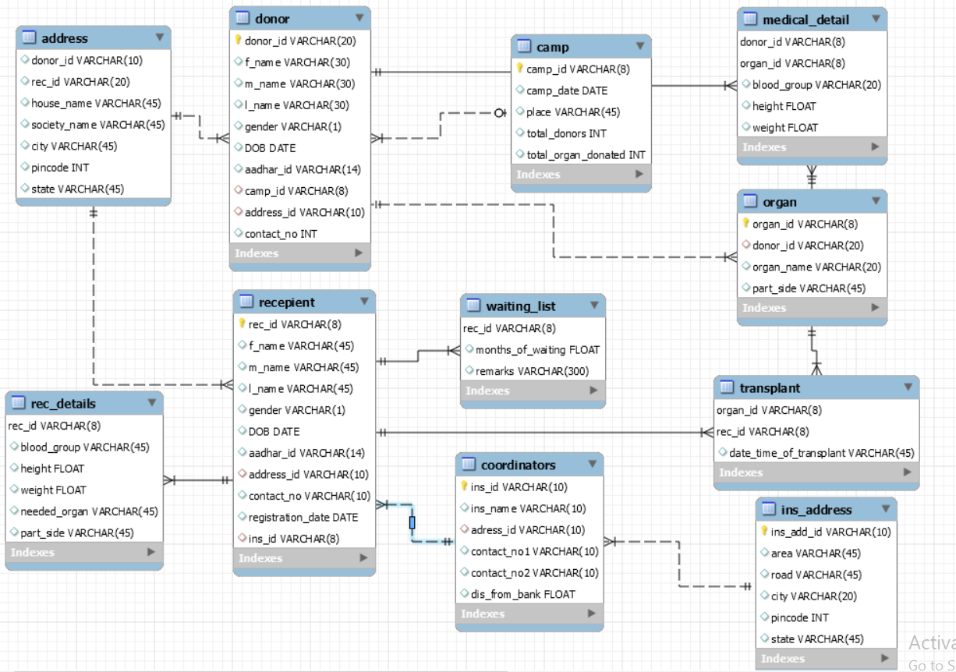

**1.2.4 Indexes:**

**camp:**

|  |  |  |  |  |  |  |  |
| --- | --- | --- | --- | --- | --- | --- | --- |
| **Keyname** | **Type** | **Unique** | **Packed** | **Column** | **Cardinality** | **Collation** | **Null** |
| PRIMARY | BTREE | Yes | No | camp_id | 5 | A | No |

**coordinators:**

|  |  |  |  |  |  |  |  |
| --- | --- | --- | --- | --- | --- | --- | --- |
| **Keyname** | **Type** | **Unique** | **Packed** | **Column** | **Cardinality** | **Collation** | **Null** |
| PRIMARY | BTREE | Yes | No | ins_id | 6 | A | No |

**donor:**

|  |  |  |  |  |  |  |  |
| --- | --- | --- | --- | --- | --- | --- | --- |
| **Keyname** | **Type** | **Unique** | **Packed** | **Column** | **Cardinality** | **Collation** | **Null** |
| PRIMARY | BTREE | Yes | No | donor_id | 17 | A | No |

**ins_address:**

|  |  |  |  |  |  |  |  |
| --- | --- | --- | --- | --- | --- | --- | --- |
| **Keyname** | **Type** | **Unique** | **Packed** | **Column** | **Cardinality** | **Collation** | **Null** |
| PRIMARY | BTREE | Yes | No | ins_add_id | 6 | A | No |

**medical_detail:**

|  |  |  |  |  |  |  |  |
| --- | --- | --- | --- | --- | --- | --- | --- |
| **Keyname** | **Type** | **Unique** | **Packed** | **Column** | **Cardinality** | **Collation** | **Null** |
| organ_id | BTREE | No | No | organ_id | 18 | A | No |
| PRIMARY | BTREE | Yes | No | donor_id | 18 | A | No |
| organ_id | 18 | A | No |

**organ:**

|  |  |  |  |  |  |  |  |
| --- | --- | --- | --- | --- | --- | --- | --- |
| **Keyname** | **Type** | **Unique** | **Packed** | **Column** | **Cardinality** | **Collation** | **Null** |
| PRIMARY | BTREE | Yes | No | organ_id | 20 | A | No |

**recipient:**

|  |  |  |  |  |  |  |  |
| --- | --- | --- | --- | --- | --- | --- | --- |
| **Keyname** | **Type** | **Unique** | **Packed** | **Column** | **Cardinality** | **Collation** | **Null** |
| PRIMARY | BTREE | Yes | No | rec_id | 12 | A | No |

**recepient_details**

|  |  |  |  |  |  |  |  |
| --- | --- | --- | --- | --- | --- | --- | --- |
| **Keyname** | **Type** | **Unique** | **Packed** | **Column** | **Cardinality** | **Collation** | **Null** |
| **PRIMARY** | **BTREE** | **Yes** | **No** | **rec_id** | **13** | **A** | **No** |

**transplant**

|  |  |  |  |  |  |  |  |
| --- | --- | --- | --- | --- | --- | --- | --- |
| **Keyname** | **Type** | **Unique** | **Packed** | **Column** | **Cardinality** | **Collation** | **Null** |
| rec_id | BTREE | No | No | rec_id | 7 | A | No |
| PRIMARY | BTREE | Yes | No | organ_id | 7 | A | No |
| rec_id | 7 | A | No |

**waiting_list**

|  |  |  |  |  |  |  |  |
| --- | --- | --- | --- | --- | --- | --- | --- |
| **Keyname** | **Type** | **Unique** | **Packed** | **Column** | **Cardinality** | **Collation** | **Null** |
| PRIMARY | BTREE | Yes | No | rec_id | 7 | A | No |

**1.3 Functionalities used in Backend:**

**1.3.1 Stored Procedures**

1. **To display details of the camps in the hospital page**

DELIMITER $$

CREATE PROCEDURE `camp_det`()

begin

select camp_id, place, camp_date, total_donors, total_organ_donated from camp ;

end$$

DELIMITER ;

$query = "call camp_det()";

$query_run = mysqli_query($connection, $query);

while ($row = mysqli_fetch_assoc($query_run)) {

$place = $row['place'];

$camp_date = $row['camp_date'];

1. **Display details of the respective organ**

DELIMITER $$

CREATE PROCEDURE `Organ_data`(IN `organ` VARCHAR(20), IN `part` VARCHAR(30))

BEGIN

select medical_detail.blood_group, medical_detail.height, medical_detail.weight from medical_detail left join organ on

organ.organ_id=medical_detail. organ_id where organ.organ_name=organ and organ.part_side=part;

END$$

DELIMITER ;

$query = "call Organ_data('$_POST[o_name]','$_POST[part]')";

$query_run = mysqli_query($connection, $query);

while ($row = mysqli_fetch_assoc($query_run)) {

$blood_group = $row['blood_group'];

$height = $row['height'];

$weight = $row['weight'];

1. **To display the recipient's details of the respective hospital**

DELIMITER $$

CREATE PROCEDURE `rec_detailOf_Hospital`(IN `ins_id1` VARCHAR(8))

BEGIN

SELECT

recepient.rec_id, recepient.f_name, recepient.m_name, recepient.l_name, recepient.gender, recepient.DOB, recepient.aadhar_id, recepient.contact_no,

recepient.registration_date, rec_details.blood_group, rec_details.height, rec_details.weight, rec_details.needed_organ, rec_details.part_side, address.house_name, address.society_name, address.city, address.pincode, address.state

from recepient, rec_details,address

where trim(recepient.ins_id)=ins_id1 and trim(recepient.rec_id)=trim(rec_details.rec_id )and trim(address.rec_id)=trim(recepient.rec_id);

END$$

DELIMITER ;

$query = "call rec_detailOf_Hospital('$_SESSION[user]')";

$query_run = mysqli_query($connection, $query);

while ($row = mysqli_fetch_assoc($query_run)){

$f_name = $row['f_name']; $m_name = $row['f_name'];

$l_name = $row['l_name']; $gender = $row['gender'];

$DOB = $row['DOB']; $aadhar_id = $row['aadhar_id'];

$contact_no = $row['contact_no'];

$registration_date = $row['registration_date'];

$blood_group=$row['blood_group'];$height=$row['height'];

$weight=$row['weight'];$needed_organ=$row['needed_organ'];

$part=$row['part_side'];$house_name = $row['house_name'];

$society_name= $row['society_name'];$city = $row['city'];

$pincode = $row['pincode'];$state = $row['state'];

1. **To display Camp details in the admin page**

DELIMITER $$

CREATE PROCEDURE `camp_det`()

begin

select camp_id, place, camp_date, total_donors, total_organ_donated from camp ;

end$$

DELIMITER ;

$query = "call camp_det()";

$query_run = mysqli_query($connection, $query

while ($row = mysqli_fetch_assoc($query_run)){

$camp_id = $row["camp_id"];

$place = $row['place'];

$camp_date = $row['camp_date'];

$total_donors=$row['total_donors'];

$total_organs=$row['total_organ_donated']

1. **To display coordinators details in the admin page**

DELIMITER $$

CREATE PROCEDURE `coordinators_det`()

BEGIN

select coordinators.ins_name,coordinators.contact_no1, coordinators.contact_no2,

ins_address.area, ins_address.road, ins_address.city, ins_address.pincode,

ins_address.state, coordinators.dis_from_bank

from coordinators, ins_address

where coordinators.adress_id = ins_address.ins_add_id;

END$$

DELIMITER ;

$query = "call coordinators_det()";

$query_run = mysqli_query($connection, $query);

while ($row = mysqli_fetch_assoc($query_run)){

$ins_name = $row['ins_name'];

$contact_no1 = $row['contact_no1'];

$contact_no2= $row['contact_no1'];

$area = $row['area'];

$road = $row['road'];

$city = $row['city'];

$pincode = $row['pincode'];

$state = $row['state'];

$dis_from_bank = $row['dis_from_bank'];

1. **To display donor details in the admin page**

DELIMITER $$

CREATE PROCEDURE `donor_det`()

BEGIN

select donor.f_name, donor.m_name, donor.l_name, donor.gender, donor.DOB, donor.aadhar_id, donor.contact_no, address.house_name, address.society_name, address.city, address.pincode, address.state

from donor, address

where donor.donor_id = address.donor_id;

END$$

DELIMITER ;

$query = "call donor_det()";

$query_run = mysqli_query($connection, $query);

while ($row = mysqli_fetch_assoc($query_run)){

$f_name = $row['f_name'];

$m_name = $row['f_name'];

$l_name = $row['l_name'];

$gender = $row['gender'];

$DOB = $row['DOB'];

$aadhar_id = $row['aadhar_id'];

$contact_no = $row['contact_no'];

$house_name = $row['house_name'];

$society_name= $row['society_name'];

$city = $row['city'];

$pincode = $row['pincode'];

$state = $row['state'];

1. **To display donor’s medical details in the admin page**

DELIMITER $$

CREATE PROCEDURE `donor_med_det`()

BEGIN

select donor.f_name, donor.m_name, donor.l_name, donor.gender, organ.organ_name, organ.part_side, medical_detail.blood_group, medical_detail.height, medical_detail.weight

from donor, organ, medical_detail

where donor.donor_id = organ.donor_id and organ.organ_id=medical_detail.organ_id;

END$$

DELIMITER ;

$query = "call donor_med_det()";

$query_run = mysqli_query($connection, $query);

while ($row = mysqli_fetch_assoc($query_run)){

$f_name = $row['f_name'];

$m_name = $row['m_name'];

$l_name = $row['l_name'];

$gender = $row['gender'];

$organ_name = $row['organ_name'];

$part_side = $row['part_side'];

$blood_group= $row['blood_group'];

$height = $row['height'];

$weight= $row['weight'];

1. **To display recipient details in the admin page**

DELIMITER $$

CREATE PROCEDURE `admin_rec_det`()

BEGIN

select recepient.f_name, recepient.m_name, recepient.l_name, recepient.gender, recepient.DOB, recepient.aadhar_id, recepient.contact_no, coordinators.ins_name, recepient.registration_date, address.house_name, address.society_name, address.city, address.pincode, address.state

from recepient, address, coordinators

where recepient.rec_id = address.rec_id and recepient.ins_id =coordinators.ins_id;

END$$

DELIMITER ;

$query = "call admin_rec_det()";

$query_run = mysqli_query($connection, $query);

while ($row = mysqli_fetch_assoc($query_run)){

$f_name = $row['f_name'];

$m_name = $row['m_name'];

$l_name = $row['l_name'];

$gender = $row['gender'];

$DOB = $row['DOB'];

$aadhar_id = $row['aadhar_id'];

$contact_no = $row['contact_no'];

$ins_name = $row['ins_name'];

$registration_date = $row['registration_date'];

$house_name = $row['house_name'];

$society_name= $row['society_name'];

$city = $row['city'];

$pincode = $row['pincode'];

$state = $row['state'];

1. **To display recipient’s medical details in the admin page**

DELIMITER $$

CREATE PROCEDURE `rec_med_det`()

BEGIN

select recepient.f_name, recepient.m_name, recepient.l_name, recepient.gender, rec_details.needed_organ, rec_details.part_side, rec_details.blood_group, rec_details.height, rec_details.weight

from recepient, rec_details

where recepient.rec_id = rec_details.rec_id;

END$$

DELIMITER ;

$query = "call rec_med_det()";

$query_run = mysqli_query($connection, $query);

while ($row = mysqli_fetch_assoc($query_run)){

$f_name = $row['f_name'];$m_name = $row['m_name'];

$l_name = $row['l_name'];$gender = $row['gender'];

$needed_organ = $row['needed_organ'];$part_side = $row['part_side'];

$blood_group= $row['blood_group'];$height = $row['height'];

$weight= $row['weight'];

1. **To display organ and its quantity**

DELIMITER $$

CREATE PROCEDURE `total_organ`()

BEGIN

select organ_name,count(organ_name) from organ group by organ_name;

END$$

DELIMITER ;

$query = "CALL total_organ()";

$query_run = mysqli_query($connection, $query);

while ($row = mysqli_fetch_assoc($query_run)){

$organ_name = $row["organ_name"];

$total = $row['count(organ_name)'];

1. **The Matching process of the organs of recipient and donor**

DELIMITER $$

CREATE PROCEDURE `matching`(IN `organName` VARCHAR(20), IN `bloodgroup` VARCHAR(10), IN `part` VARCHAR(20))

BEGIN

select distinct organ.organ_id,medical_detail.height,medical_detail.weight from organ,medical_detail where organ.organ_name=organName and organ.part_side=part

and medical_detail.blood_group=bloodgroup and organ.organ_id=medical_detail.organ_id and o_flag=0;

END$$

DELIMITER

$query = "call matching ('$_POST[o_name]','$_POST[blood_group]','$_POST[part]')";

$query_run = mysqli_query($connection, $query);

while ($row = mysqli_fetch_assoc($query_run)) {

$o_id = $row['organ_id'];

$height = $row['height'];

$weight = $row['weight'];

**1.3.2 Executing function**

1. **Number of Organs in bank**

DELIMITER $$

CREATE FUNCTION `count_organ`( ) RETURNS int(11)

BEGIN

DECLARE r_organ int;

DEClARE c_organ

CURSOR FOR

select count(organ_id) as count from organ;

open c_organ;

FETCH c_organ INTO r_organ;

Return r_organ;

END$$

DELIMITER ;

$query6="call count_organ()";

$result6= mysqli_query($connection,$query6) or die(mysqli_error($link));

while ($row = mysqli_fetch_assoc($result6)){

$r_organ=$row["r_organ"];}

1. **Total number of the recipient in the institute**

DELIMITER $$

CREATE FUNCTION `count_recepiant`(institution_id varchar(8) ) RETURNS int(11)

DETERMINISTIC

BEGIN

DECLARE r_count int;

DEClARE c_count

CURSOR FOR

select count(rec_id) as count from recepient where ins_id= institution_id;

open c_count;

FETCH c_count INTO r_count;

RETURN r_count;

END$$

DELIMITER ;

$query="call count_recepiant_hos('$_SESSION[user]')";

$result = mysqli_query($connection, $query) or die(mysqli_error($link));

while ($row = mysqli_fetch_assoc($result)){

$r_count=$row["r_count"];}

1. **Total number of the donors in bank**

DELIMITER $$

CREATE FUNCTION count_donor()

RETURNS INTEGER

DETERMINISTIC

BEGIN

DECLARE r_donor int;

DEClARE c_donor

CURSOR FOR

select count(donor_id) as count from donor;

open c_donor;

FETCH c_donor INTO r_donor;

RETURN r_donor;

END$$

DELIMITER ;

$query="call count_donor()";

$result = mysqli_query($connection, $query) or die(mysqli_error($link));

while ($row = mysqli_fetch_assoc($result)){

$r_count=$row["r_donor"];}

1. **Total number of the recipients in bank**

DELIMITER $$

CREATE FUNCTION count_rec()

RETURNS INTEGER

DETERMINISTIC

BEGIN

DECLARE r_rec int;

DEClARE c_rec

CURSOR FOR

select count(rec_id) as count from recepient;

open c_rec;

FETCH c_rec INTO r_rec;

RETURN r_rec;

END$$

DELIMITER ;

$query1="call count_rec()";

$result2 = mysqli_query($connection, $query1) or die(mysqli_error($link));

while ($row = mysqli_fetch_assoc($result2)){

$r_rec=$row["r_rec"];}

1. **Total number of the coordinators of bank**

DELIMITER $$

CREATE FUNCTION count_coor()

RETURNS INTEGER

DETERMINISTIC

BEGIN

DECLARE r_coor int;

DEClARE c_coor

CURSOR FOR

select count(ins_id) as count from coordinators;

open c_coor;

FETCH c_coor INTO r_coor;

RETURN r_coor;

END$$

DELIMITER ;

select count_coor();

$query3="call count_coor()";

$result3= mysqli_query($connection, $query3) or die(mysqli_error($link));

while ($row = mysqli_fetch_assoc($result3)){

$r_coor=$row["r_coor"];}

1. **Total number of the camps handled by bank**

DELIMITER $$

CREATE FUNCTION count_camp()

RETURNS INTEGER

DETERMINISTIC

BEGIN

DECLARE r_camp int;

DEClARE c_camp

CURSOR FOR

select count(camp_id) as count from camp;

open c_camp;

FETCH c_camp INTO r_camp;

RETURN r_camp;

END$$

DELIMITER ;

$query4="call count_camp()";

$result4= mysqli_query($connection, $query4) or die(mysqli_error($link));

while ($row = mysqli_fetch_assoc($result4)){

$r_camp=$row["r_camp"];}

1. **Total number of transplants of organs by bank**

DELIMITER $$

CREATE FUNCTION count_transplant()

RETURNS INTEGER

DETERMINISTIC

BEGIN

DECLARE r_transplant int;

DEClARE c_transplant

CURSOR FOR

select count(organ_id) as count from transplant;

open c_transplant;

FETCH c_transplant INTO r_transplant;

RETURN r_transplant;

END$$

DELIMITER ;

$query5="call count_transplant()";

$result5= mysqli_query($connection, $query5) or die(mysqli_error($link));

while ($row = mysqli_fetch_assoc($result5)){

$r_transplant=$row["r_transplant"];}

1. **Total number of recipient in waiting list**

DELIMITER $$

CREATE FUNCTION `count_wait`()

BEGIN

DECLARE r_wait int;

DEClARE c_wait

CURSOR FOR

select count(rec_id) as count from waiting_list;

open c_wait;

FETCH c_wait INTO r_wait;

Return r_wait;

end$$

DELIMITER ;

$query7="call count_wait()";

$result7= mysqli_query($connection, $query7) or die(mysqli_error($link));

while ($row = mysqli_fetch_assoc($result7)){

$r_wait=$row["r_wait"]9;}

**1.3.3 Triggers:**

1. **Donor having age less than 18 is not allowed to donate**

DELIMITER //

create trigger age before insert on donor

for each row

begin

declare msg varchar(200);

declare d1 date;

declare d2 date;

set d1:=new.DOB ;

set d2:= curdate();

if ((timestampdiff(month, d1 , d2)) < 216) then

SET msg = 'Person having age less than 18 can not donate.....';

SIGNAL SQLSTATE '45000' SET MESSAGE_TEXT = msg;

END IF;

END//

1. **Update the total number of donors in the `camp` table if a donor is added or deleted**

DELIMITER $$

create trigger inc_donors_camp after insert on donor

for each row

begin

UPDATE camp SET total_donors = total_donors + 1 where camp.camp_id = NEW.camp_id;

end//

------------------------------------------------------------------------------------------------------------

DELIMITER $$

create trigger dec_donors_camp before delete on donor

for each row

begin

UPDATE camp SET total_donors = total_donors -1 where camp.camp_id = Old.camp_id;

end//

1. **Error occurs when the donor’s first name, middle name, last name, or birthdate is not inserted by the a user**

DELIMITER $$

create trigger don_det before insert on donor

for each row

begin

declare msg varchar(100) ;

if (new.f_name is null) then

set msg = 'First name of the person can''t be null...';

SIGNAL SQLSTATE '45000' SET MESSAGE_TEXT = msg;

elseif(new.m_name is null) then

SET msg = 'Middle name of the person can''t be null...';

SIGNAL SQLSTATE '45001' SET MESSAGE_TEXT = msg;

elseif (new.l_name is null) then

SET msg ='Last name of the person can''t be null...';

SIGNAL SQLSTATE '45002' SET MESSAGE_TEXT=msg;

elseif (new.DOB is null) then

SET msg = 'Birthdate of the person can''t be null..';

SIGNAL SQLSTATE '45003' SET MESSAGE_TEXT=msg;

end if;

end//

1. **Error occurs when organ name is not inserted by user**

DELIMITER $$

CREATE TRIGGER `d_organ` BEFORE INSERT ON `organ`

FOR EACH ROW begin

declare msg varchar(200);

if (new.organ_name is null) then

SET msg = 'Please add a organ name of the donor...';

SIGNAL SQLSTATE '45000' SET MESSAGE_TEXT = msg;

end if;

End

1. **Error occurs when blood group is not inserted by user**

DELIMITER //

create trigger d_bloodgroup before insert on medical_detail

for each row

begin

declare msg varchar(200);

if (new.blood_group is null) then

SET msg = 'Please add a blood group of the donor...';

SIGNAL SQLSTATE '45000' SET MESSAGE_TEXT = msg;

end if;

end//

1. **Error occurs when recipient's first name, middle name, last name or birthdate is not inserted by user**

DELIMITER //

create trigger rec_det before insert on recepient

for each row

begin

declare msg varchar(100) ;

if (new.f_name is null) then

set msg = 'First name of the person can''t be null...';

SIGNAL SQLSTATE '45000' SET MESSAGE_TEXT = msg;

elseif(new.m_name is null) then

SET msg = 'Middle name of the person can''t be null...';

SIGNAL SQLSTATE '45001' SET MESSAGE_TEXT = msg;

elseif (new.l_name is null) then

SET msg ='Last name of the person can''t be null...';

SIGNAL SQLSTATE '45002' SET MESSAGE_TEXT=msg;

elseif (new.DOB is null) then

SET msg = 'Birthdate of the person can''t be null..';

SIGNAL SQLSTATE '45003' SET MESSAGE_TEXT=msg;

end if;

end//

1. **Error occurs when blood group or needed organ is not inserted by user**

DELIMITER $$

create trigger rec_med before insert on rec_details

for each row

begin

declare msg varchar(200);

if (new.blood_group is null) then

SET msg = 'Please add a blood group of the recepient...';

SIGNAL SQLSTATE '45000' SET MESSAGE_TEXT = msg;

elseif (new.needed_organ is null) then

SET msg = 'Please add a needed organ of recepient...';

SIGNAL SQLSTATE '45001' SET MESSAGE_TEXT = msg;

end if;

end//

1. **Inserting recipient detail in waiting list when it is inserted into `recipient` table**

DELIMITER $$

CREATE TRIGGER `waiting_list` AFTER INSERT ON `recepient`

FOR EACH ROW BEGIN

insert into waiting_list values (recepient.rec_id,TIMESTAMPDIFF(month,recepient.registration_date,CURDATE()));

END//

1. **Deleting recipient detail in waiting list when it is inserted into `transplant` table**

DELIMITER $$

CREATE TRIGGER `waiting` AFTER INSERT ON `transplant`

FOR EACH ROW begin

delete from waiting_list where rec_id=new.rec_id;

END//

1. **Deleting recipient detail in a waiting list when it is deleted from `recepient` table**

DELIMITER $$

CREATE TRIGGER `remove_waiting` AFTER DELETE ON `recepient`

FOR EACH ROW begin

delete from waiting_list where rec_id=old.rec_id;

END//

1. **Value of flag will become 1 in `recepient` and `organ` table after transplantation**

DELIMITER $$

CREATE TRIGGER `transplantation` AFTER INSERT ON `transplant`

FOR EACH ROW begin

update recepient set r_flag=1 where rec_id= NEW.rec_id;

update organ set o_flag=1 where organ_id= NEW.organ_id;

END//

**1.4 Screenshots**

**Procedure :**

1. **Camp Details for Hospital-**`camp_det`()

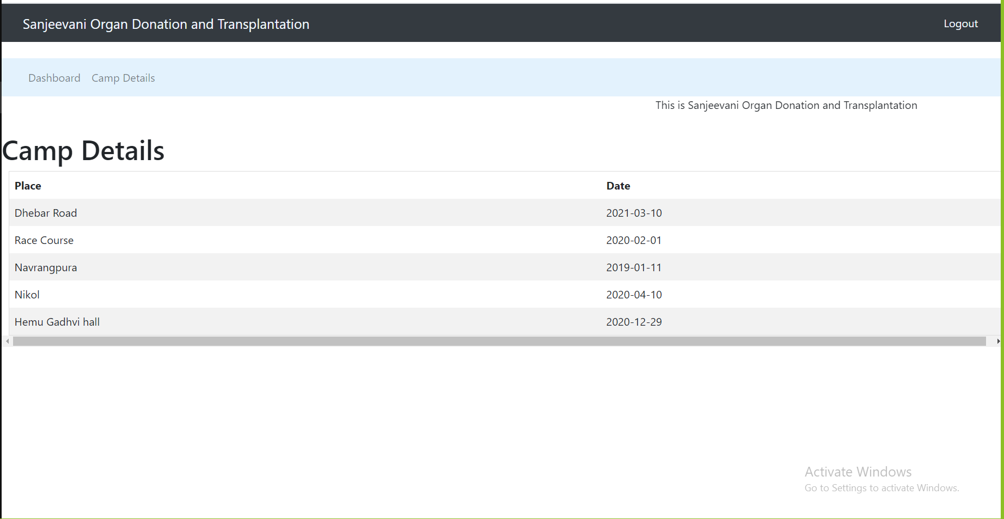

1. **Available organ details for Hospital** -`Organ_data`(IN `organ` VARCHAR(20), IN `part` VARCHAR(30))

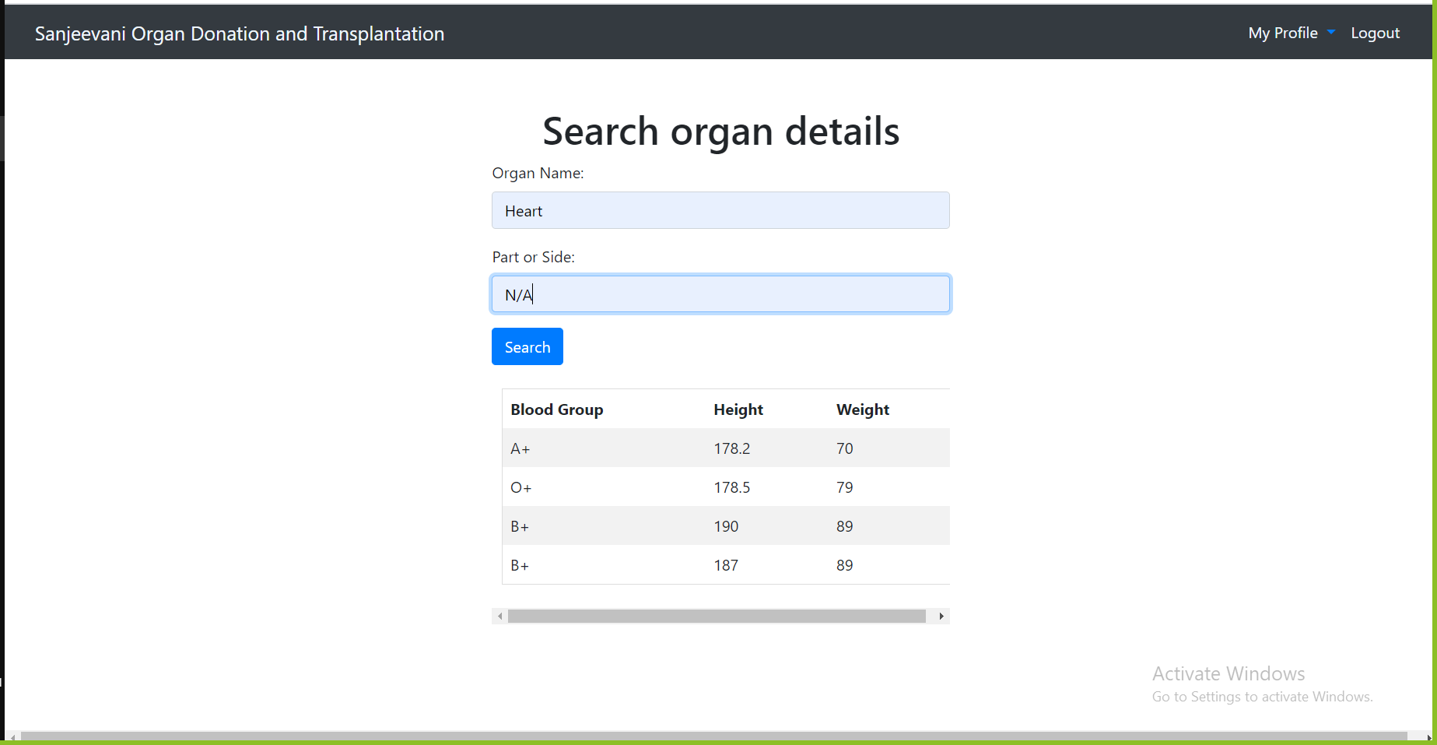

1. **Recipient Details of respective Hospital -**`rec_detailOf_Hospital`(IN `ins_id1` VARCHAR(8))

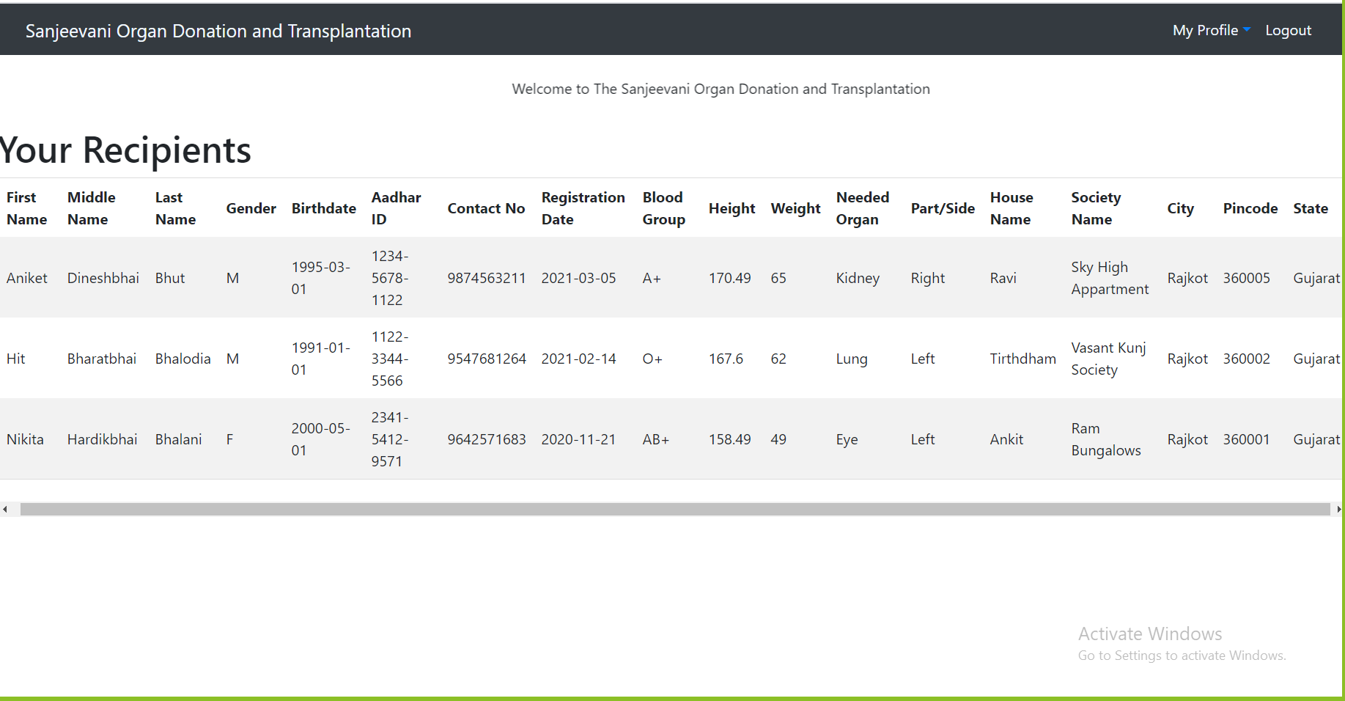

1. **Waiting List for Respective Hospital**

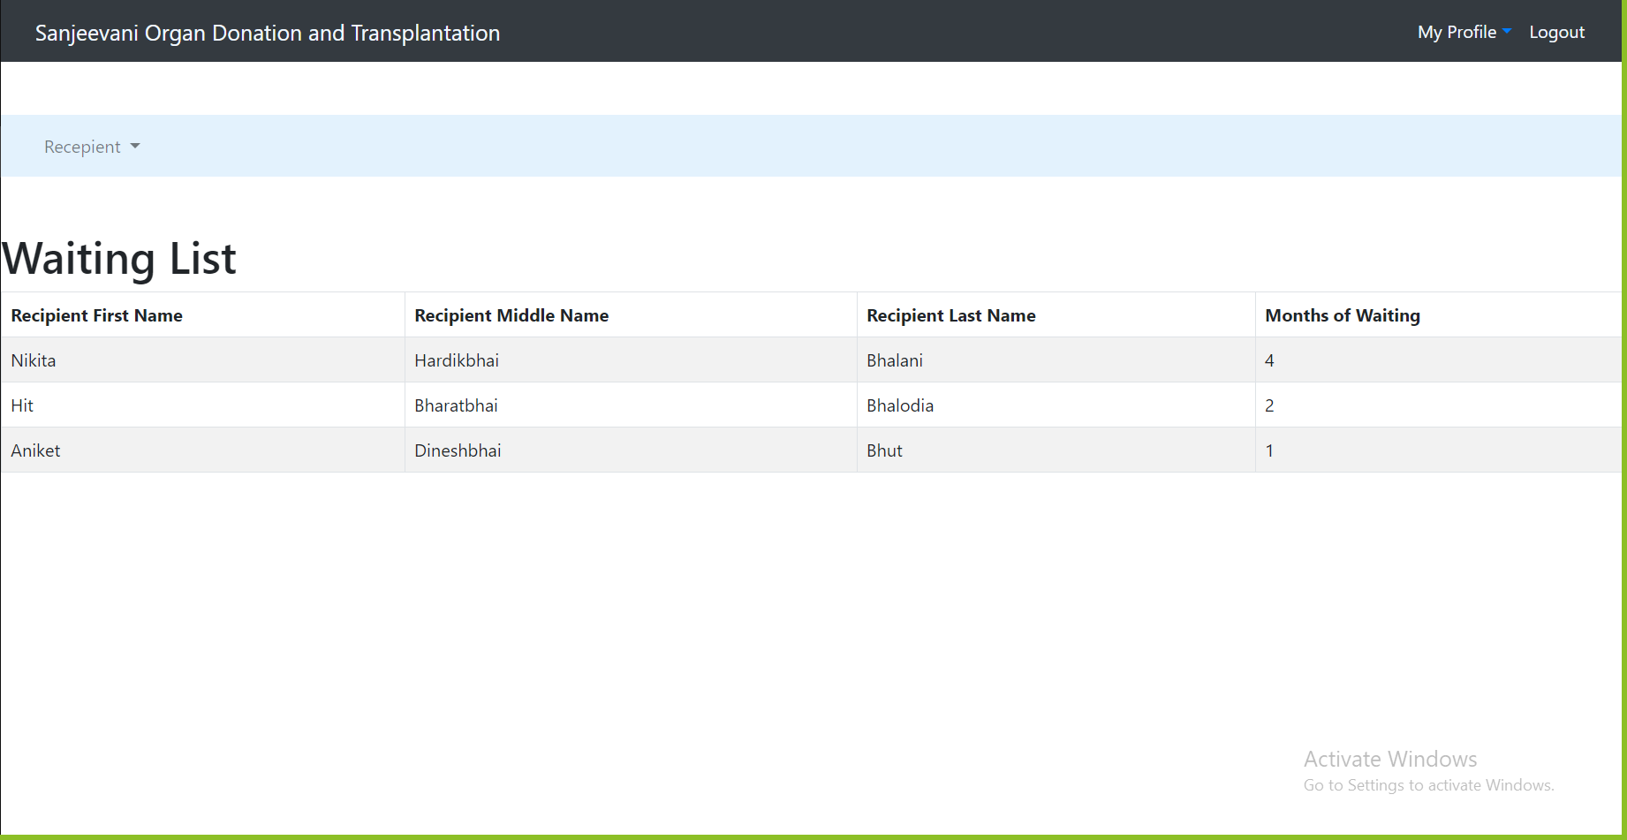

1. **View of Donor’s personal details for Admin -**`donor_det`()

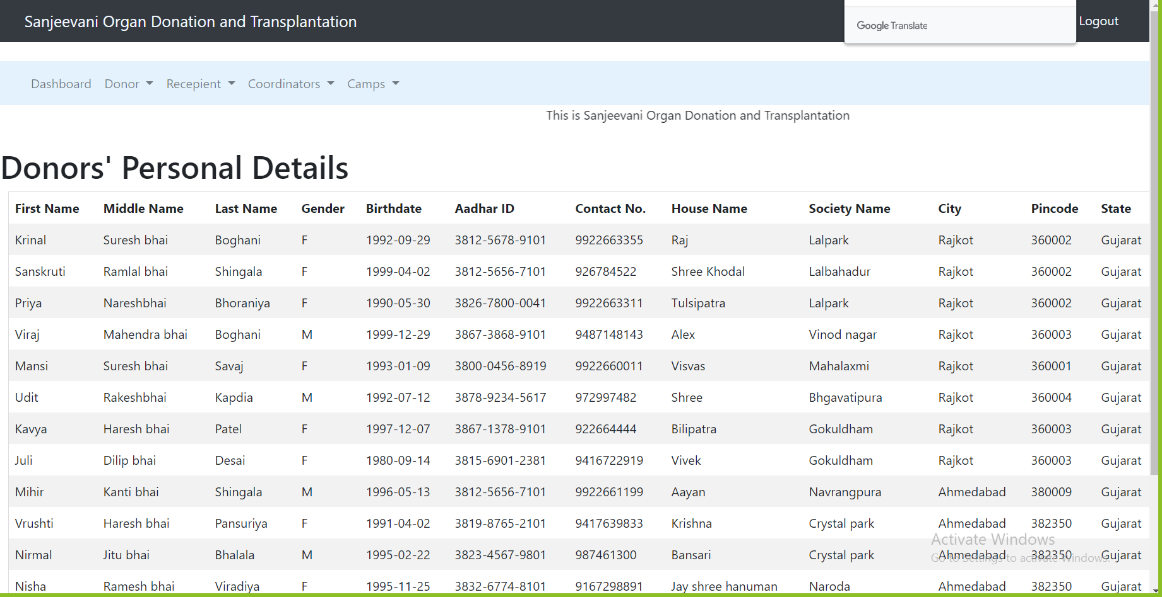

1. **View of Donor’s medical details for Admin -**`donor_med_det`()

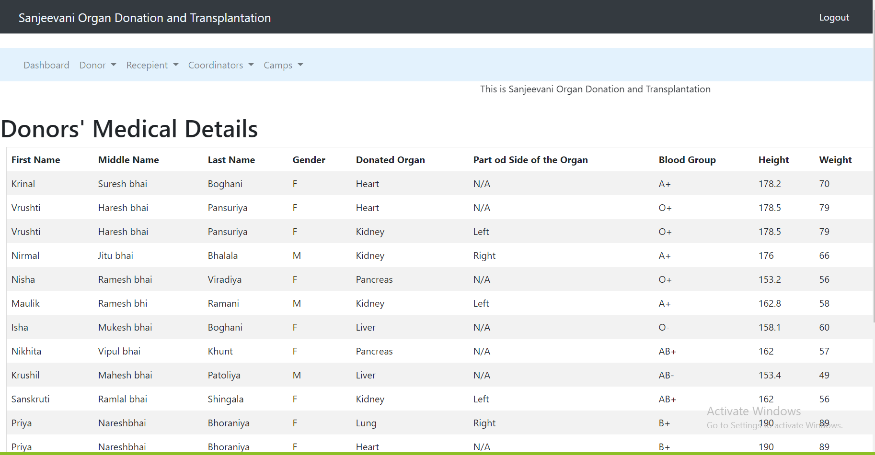

1. **View of Recipients' personal details for Admin -**`admin_rec_det`()

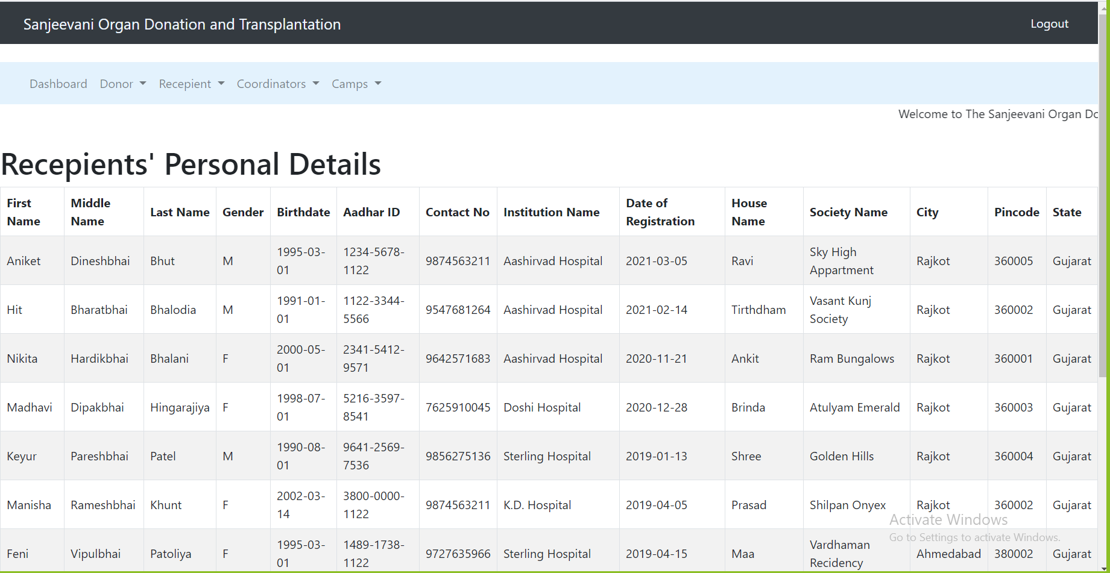

1. **View of Recipients' medical details for Admin -**`rec_med_det`()

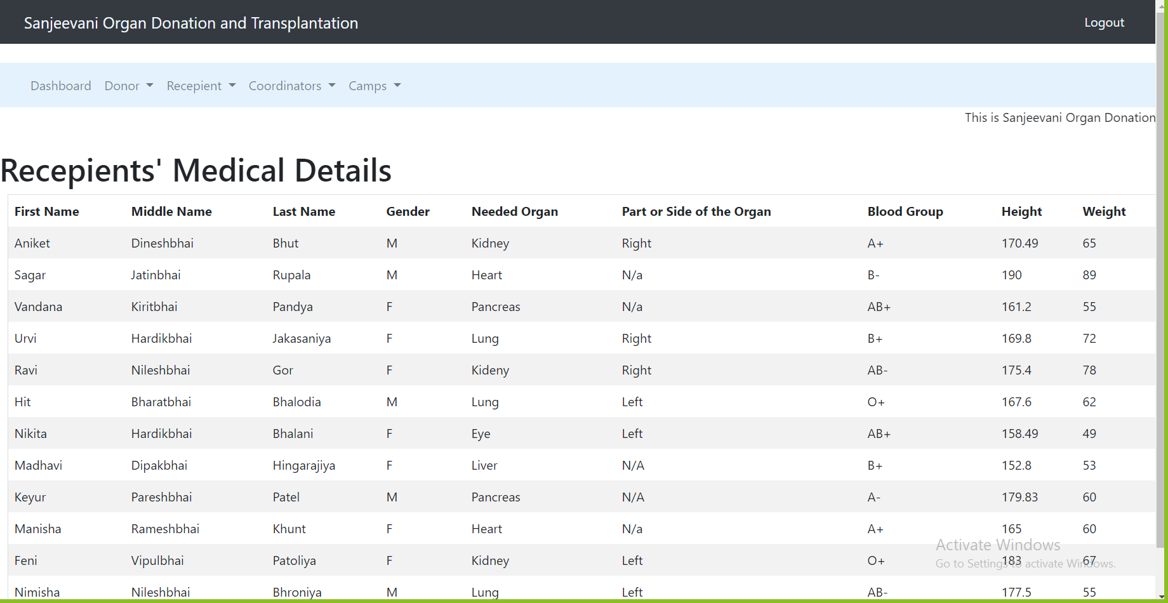

1. **View of coordinators’ details for Admin -**`coordinators_det`()

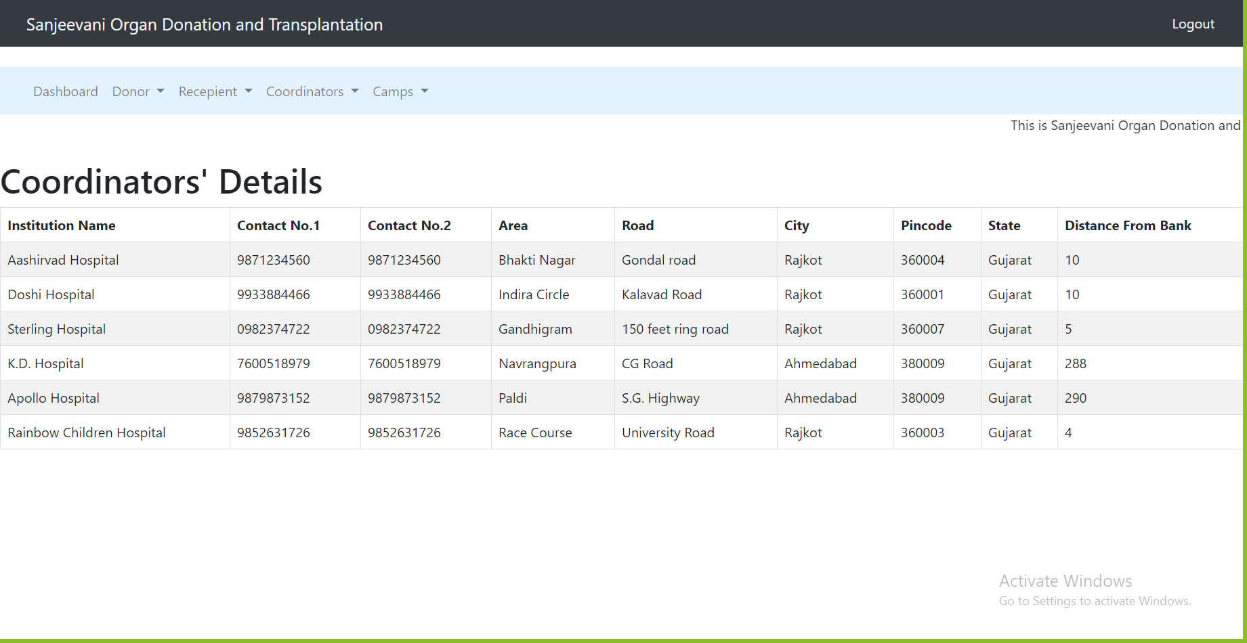

1. **View of Camps’ details for admin -**`camp_det`()

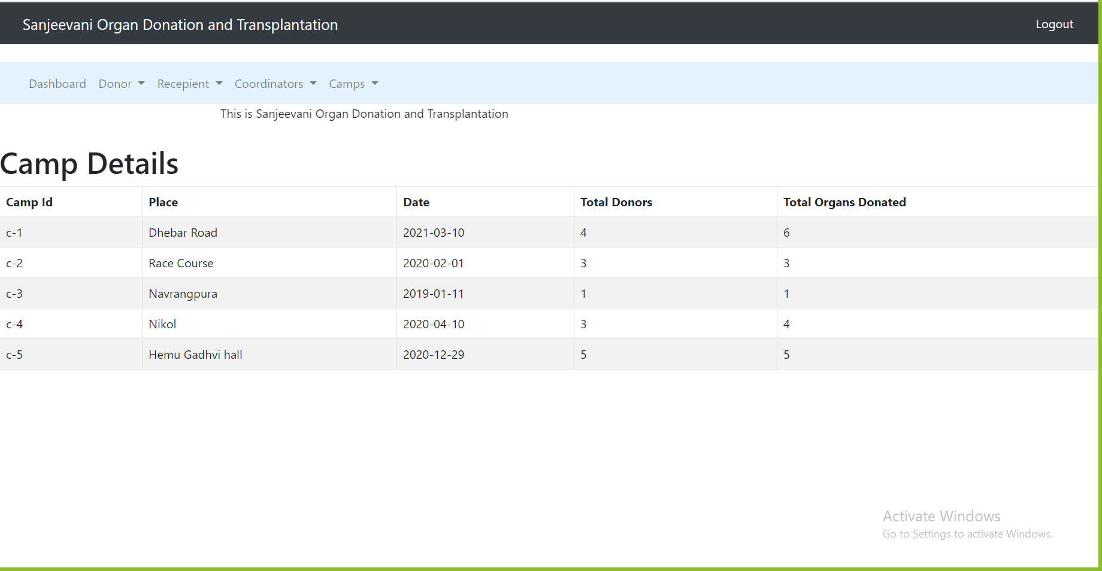

1. **View of total transplantation by the bank for admin**

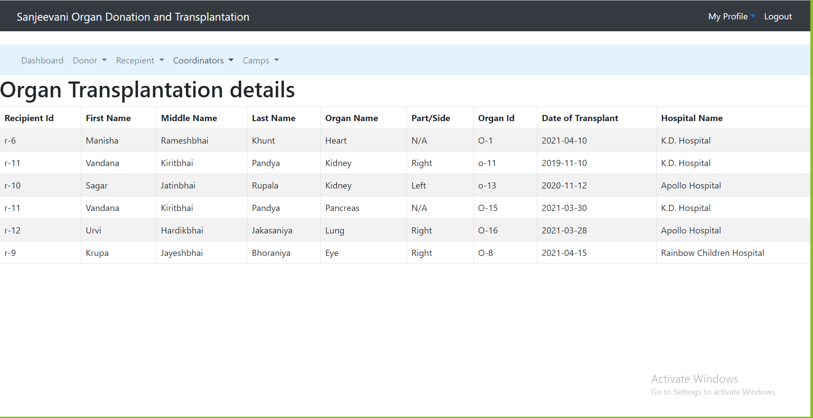

1. **View of the total quantity of respective organ -**`total_organ`()

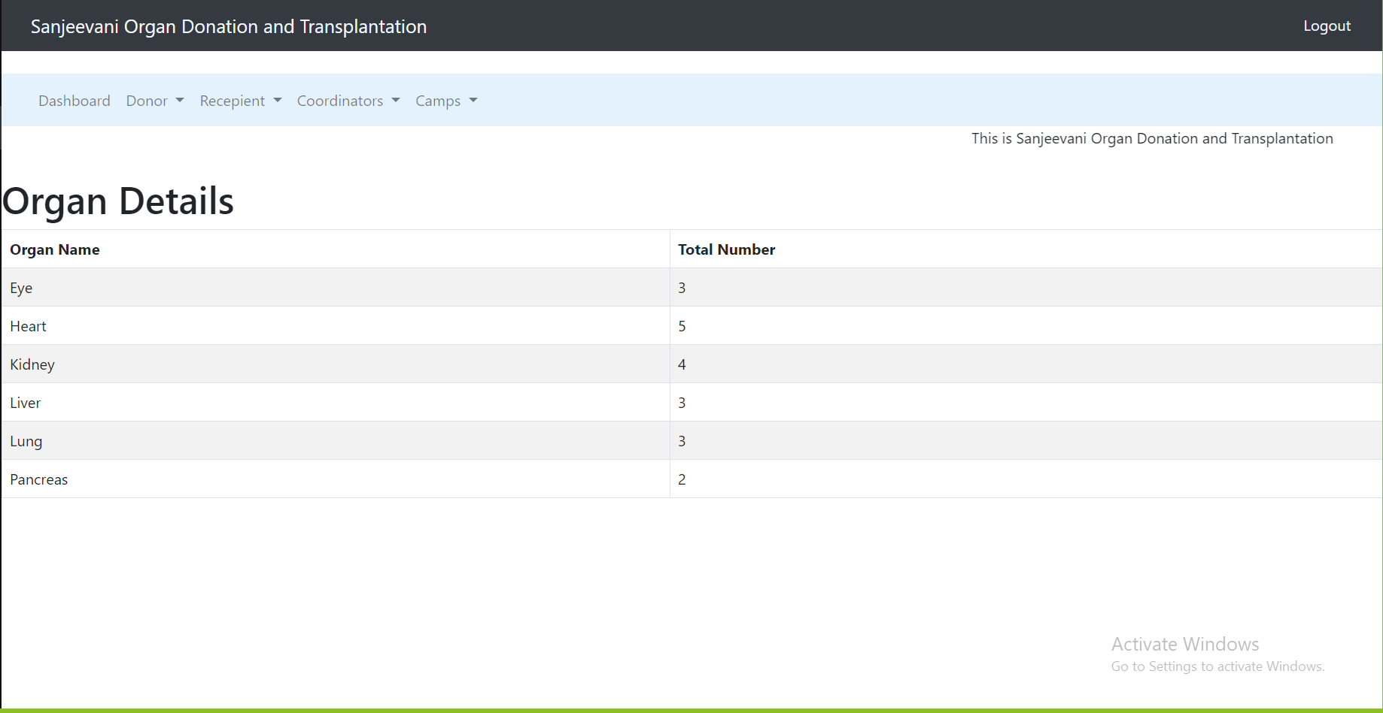

1. **View of the waiting list of the recipient for admin**

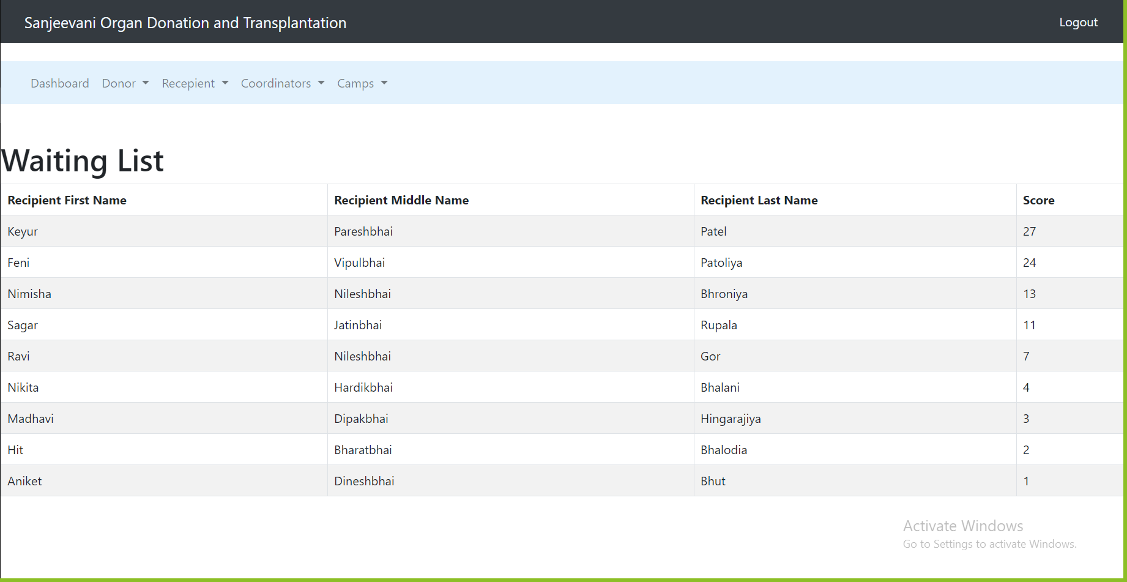

1. **Matching Process of Organ -**`matching`(IN `organName` VARCHAR(20), IN `bloodgroup` VARCHAR(10), IN `part` VARCHAR(20))

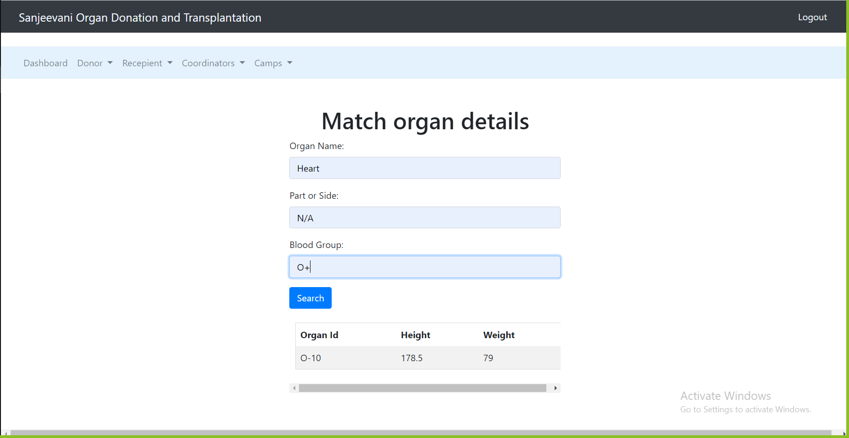

**Functions:**

1. **count_donor(), count_rec(), count_coor(), count_camp(), count_transplant(), count_organ()**

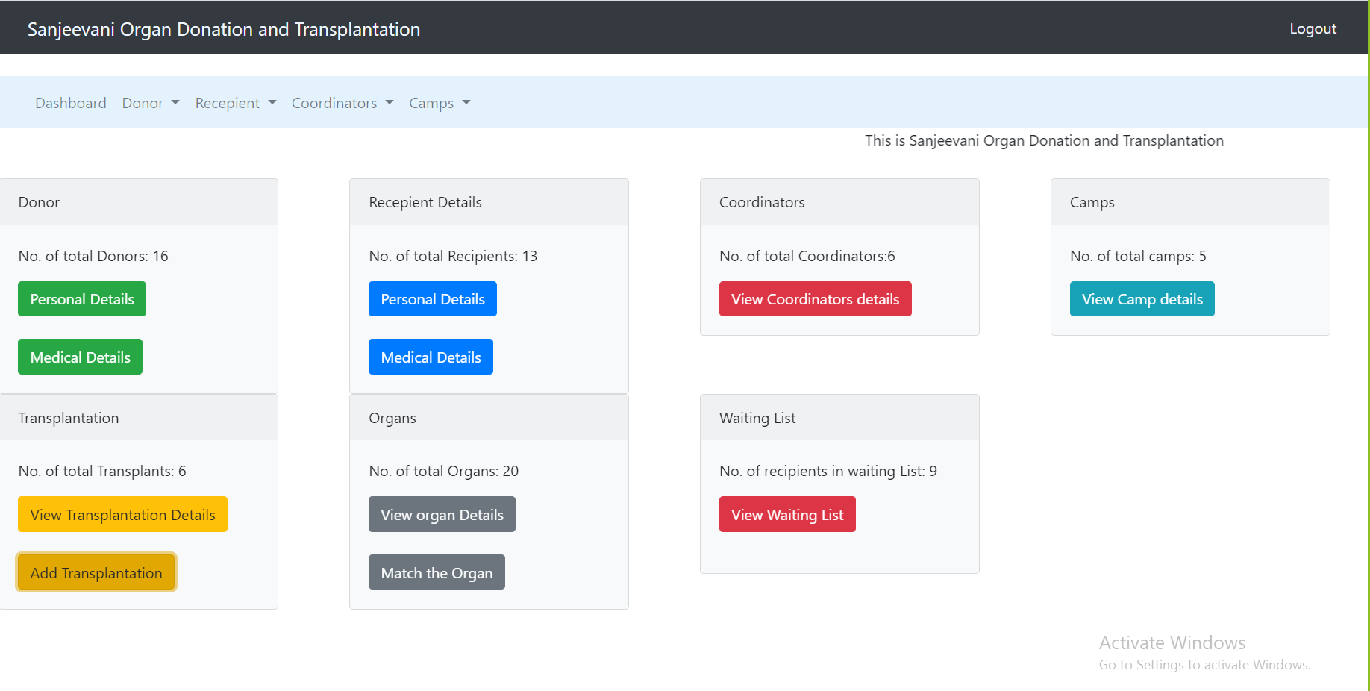

1. **`count_recepiant`(institution_id varchar(8) )**

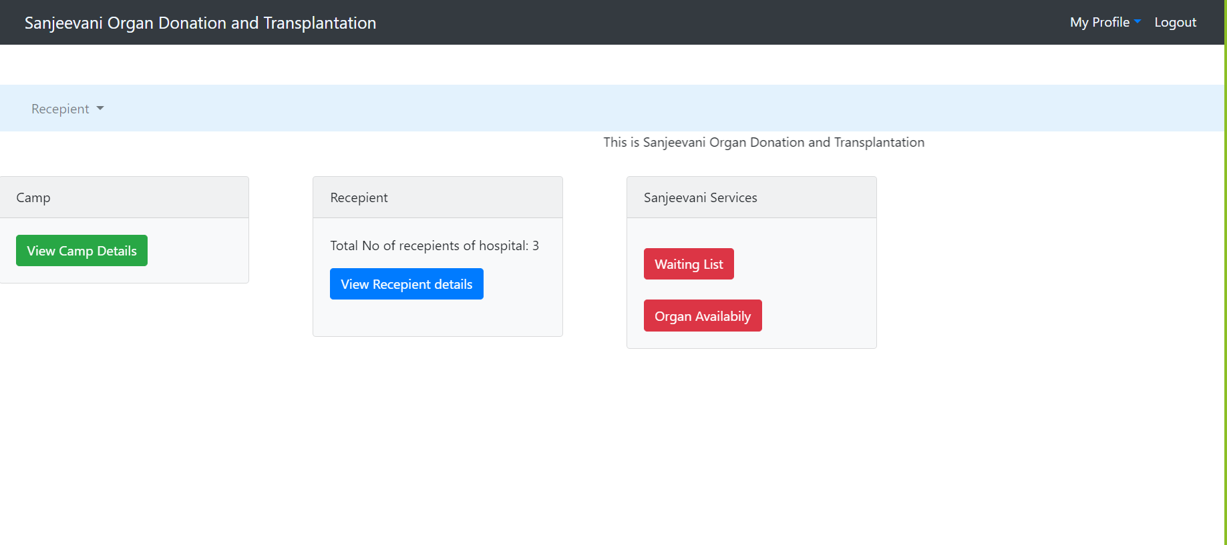

**Triggers:**

1. **Update the total number of donors in the `camp` table if a donor is added or deleted**

Initial Readings

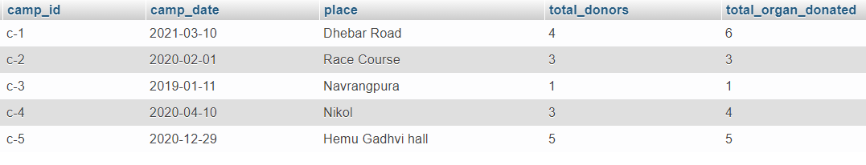

Adding a donor in camp c-3

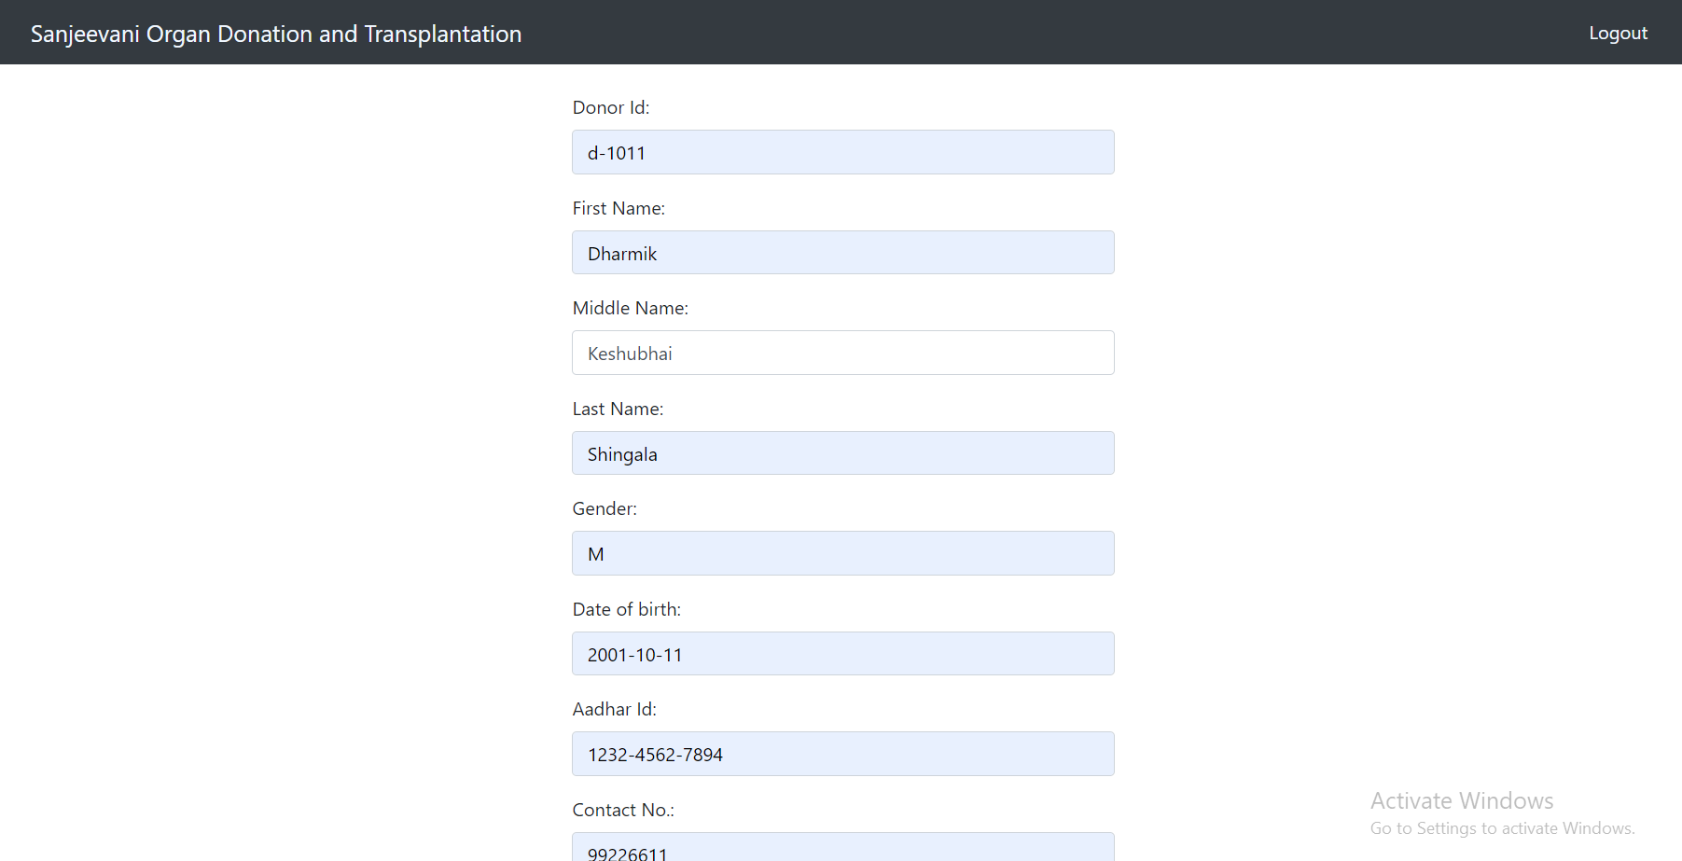

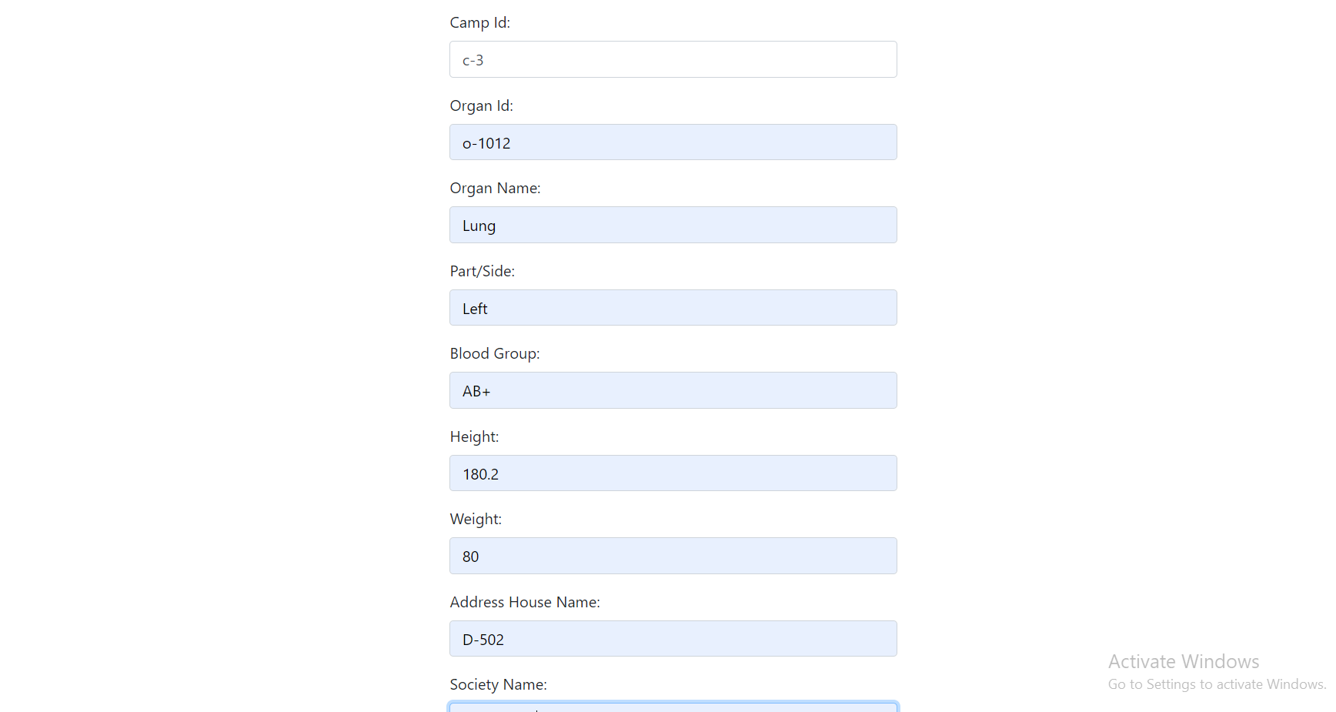



After Trigger Fired:

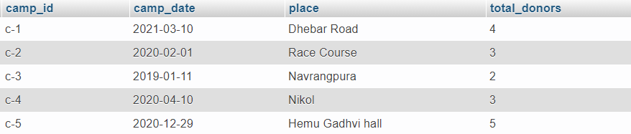

1. **Deleting recipient detail in a waiting list when it is inserted into `transplant` table**

Adding data of transplant

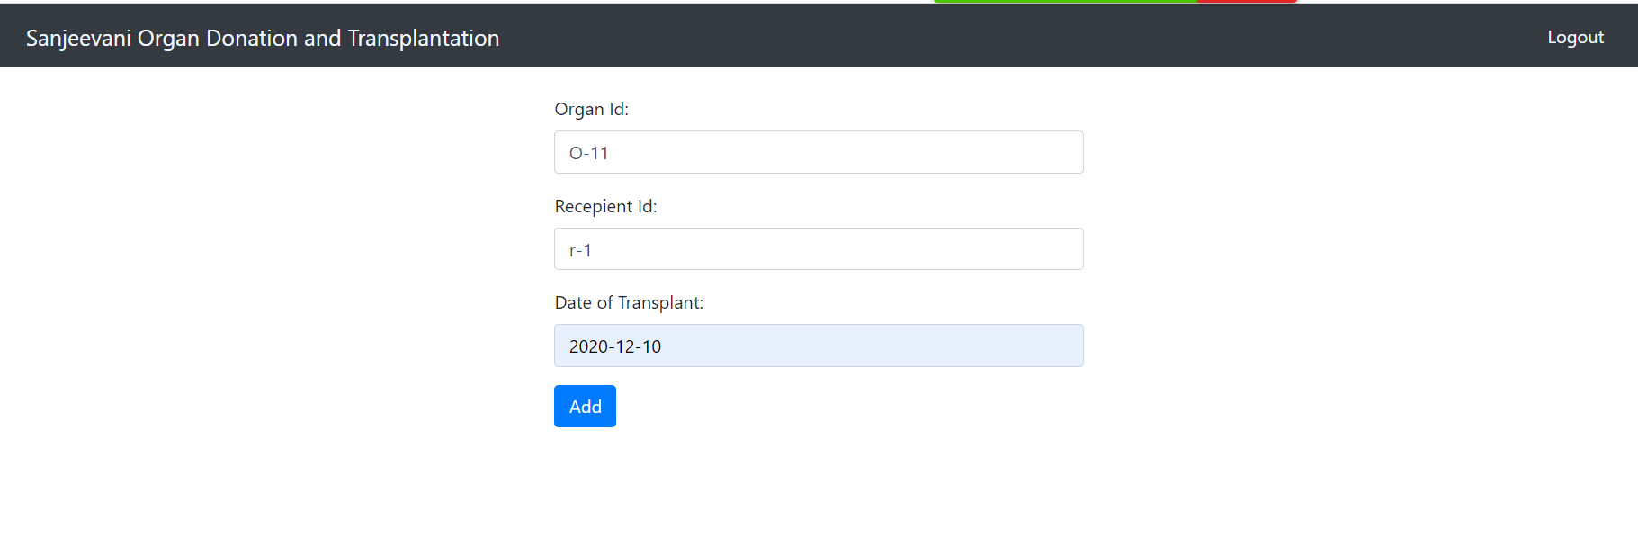

Respective Data is deleted on the waiting list table

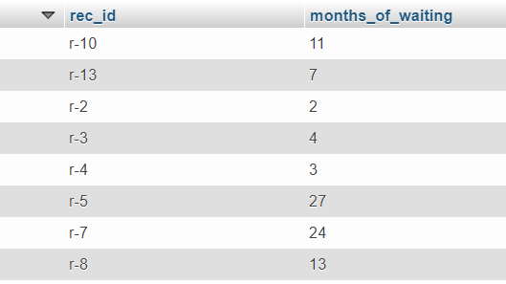

1. **Value of flag will become 1 in `recepient` and `organ` table after transplantation**

After adding data on transplant



Flag value of respective organ and recipient on their table becomes 1

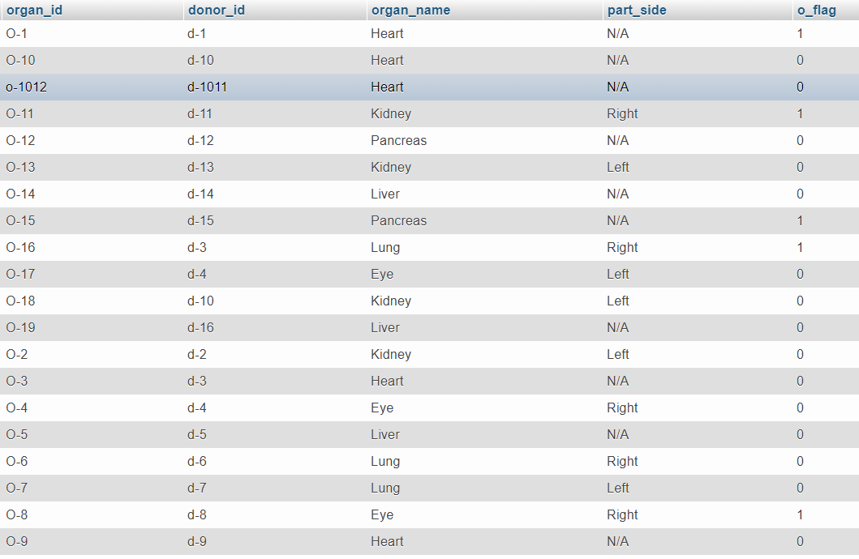



1. **Deleting recipient detail in a waiting list when it is deleted from `recepient` table**

Recipient r-13 Deleted from `recepient`table

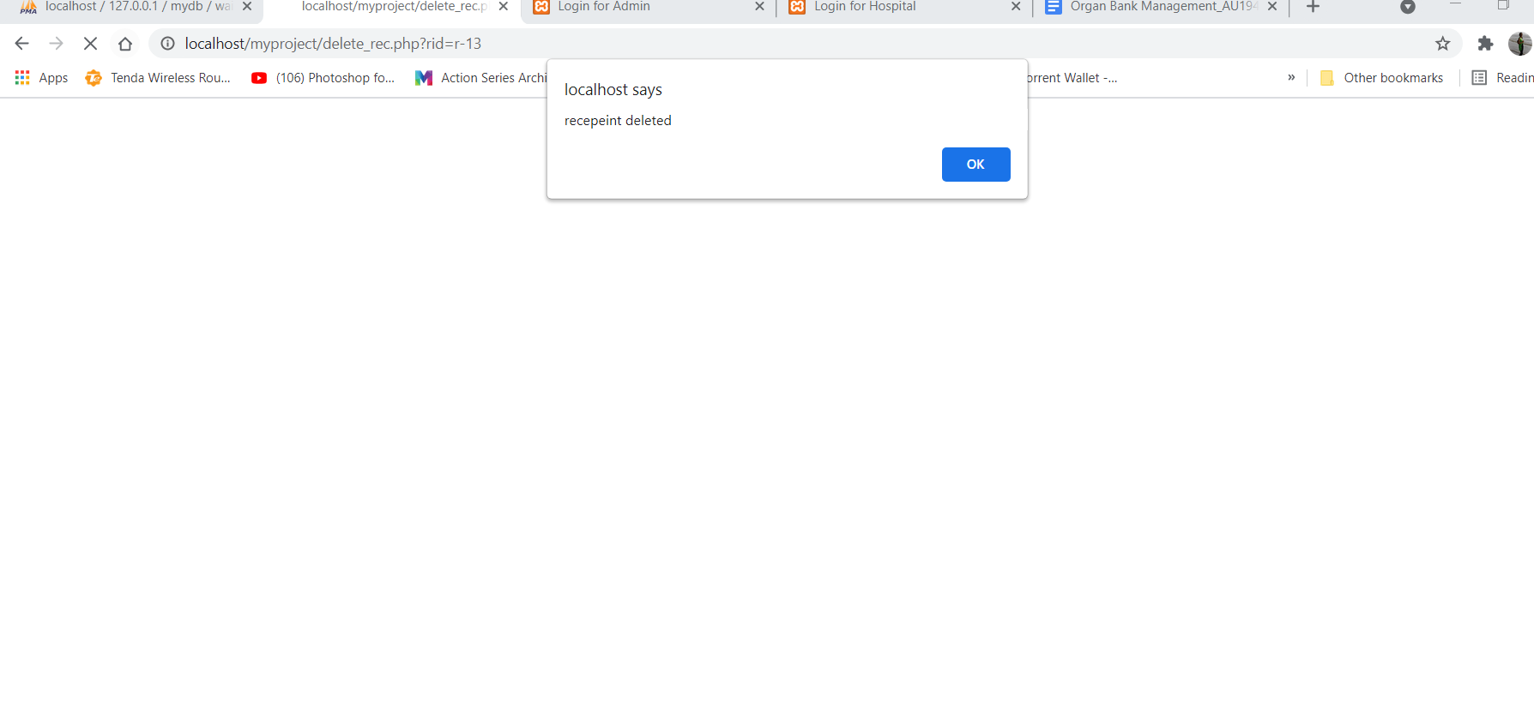

Simultaneously it deleted from the waiting list

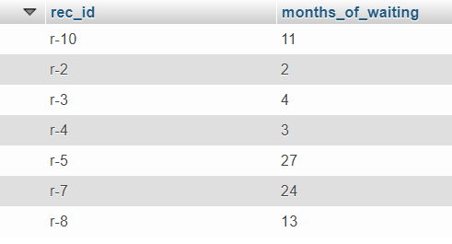

1. **The person below 18 can’t donate the organ**

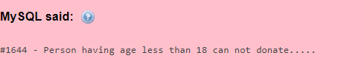

1. **First name of the donor can’t be null**



1. **Blood group of the person can’t be null**



1. **Needed organ of recipient can’t be null**

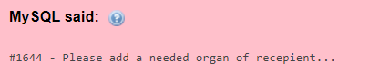

**Other Features:**

**Admin can add and manage data of Donors:**

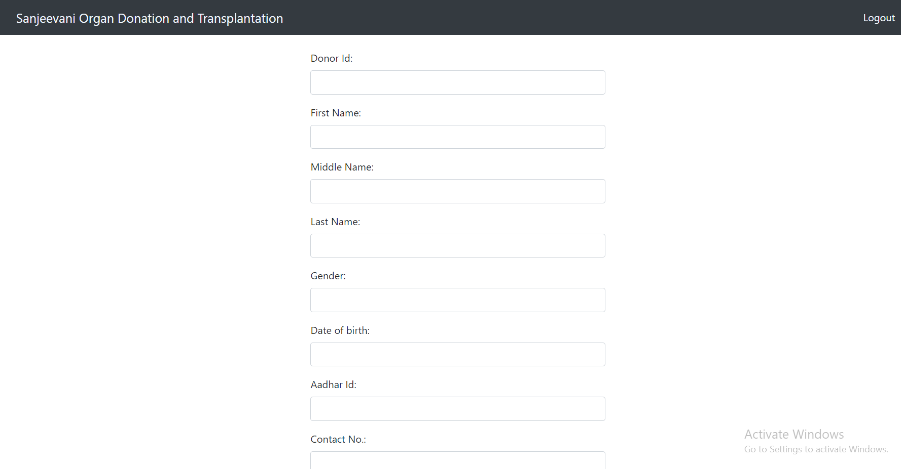

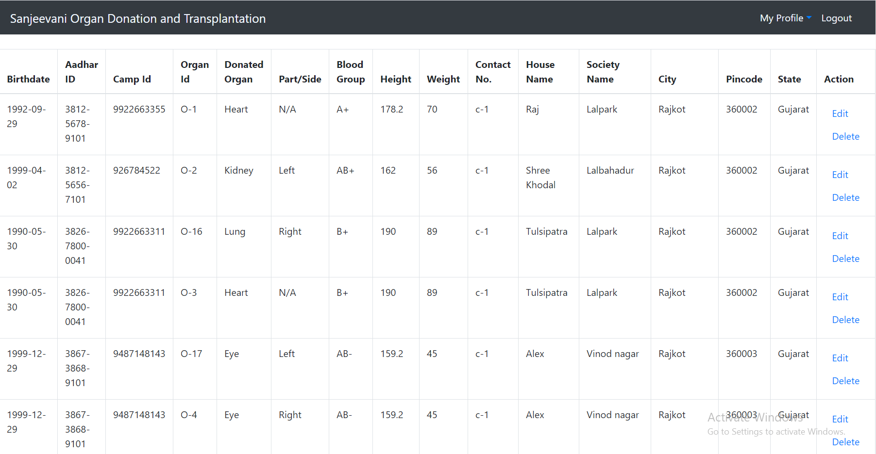

**Admin can Add and manage Coodinators’ data:**

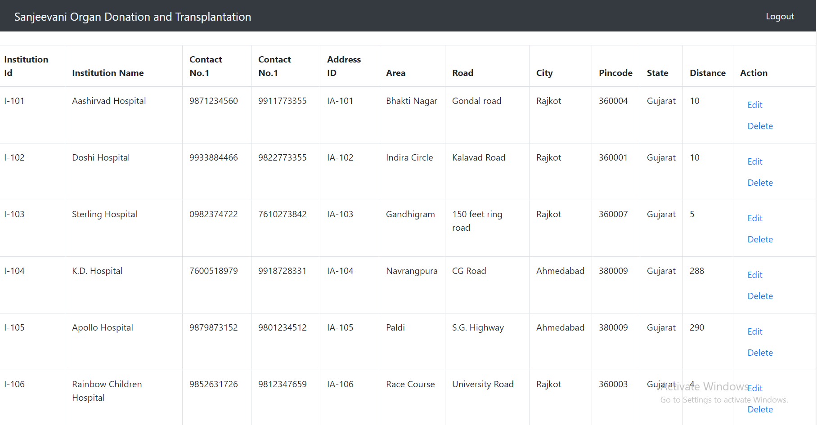

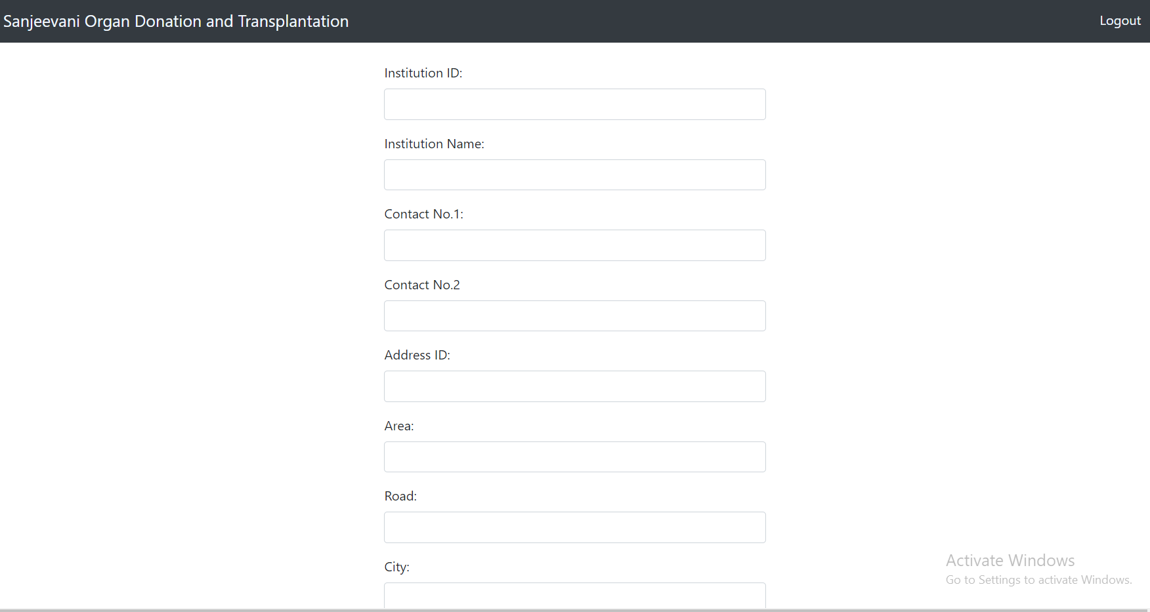



Similarly, the admin can add and manage data of camps and recipients …

**Hospital can add and manage data of their recipients**

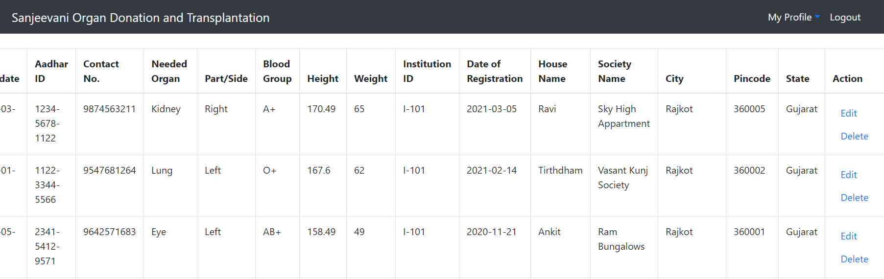

**Hospital can view and edit their profile**

